FICHA TECNICA
DELL XPS 8950 DESKTOP (12TH GEN)
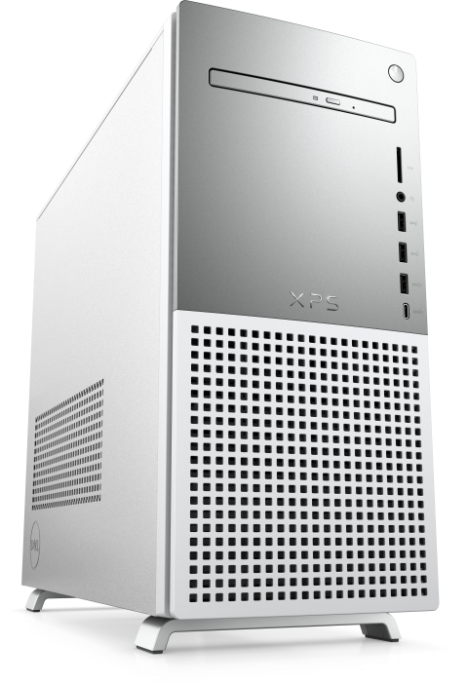
12 Gen Intel® Core™ i9-12900K (30 MB cache, 16 cores, 24 threads, 3.20 GHz to 5.20 GHz Turbo)
Memory 128GB, 4 x 32GB, DDR5, 3600 MHz
Hard Drive 1TB M.2 PCIe NVME SSD (Boot) + 2TB SATA 7200RPM HDD (Storage)
NVIDIA® GeForce RTX™ 3090, 24 GB GDDR6X
750W Platinum Silver Bezel Chassis including optical drive
Windows 11 Pro, English
Tray load DVD Drive (Reads and Writes to DVD/CD)
Killer™ Wi-Fi 6 1675 (2x2) 802.11ax Wireless and Bluetooth 5.2
Dell Multimedia Keyboard-KB216 White (English)
Wired Mouse, White MS116
McAfee LiveSafe 12 Month Subscription
Microsoft Office Professional 2021

INCLUYE:

Dell S2721QS 27 Inch 4K UHD (3840 x 2160) IPS Ultra-Thin Bezel
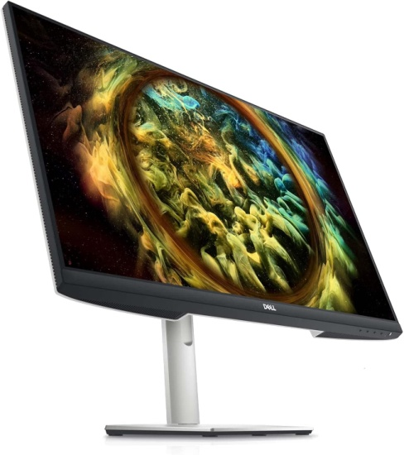

Dell KM5221W Pro Wireless Keyboard and Mouse Combo (Black)
